- Steam enters a turbine operating at steady state at 2 MPa, 360°C with a velocity of 100 m/s. Saturated vapor exits at 0.1 MPa and a velocity of 50 m/s. The elevation of the inlet is 3 m higher than at the exit. The mass flow rate of the steam is 15kg/s, and the power developed is 7 MW. Let g=9.81 m/s². Determine (a) the area at the inlet, in m², and (b) the rate of heat transfer between the turbine and its surroundings, in kW.

Information:
SISO, PE applies, KE applies, Q applies, W applies, steady state
$$0=\dot{Q}-\dot{W}+\dot{m}\left(\left(h1-h2\right)+\frac{V^{2}1-V^{2}2}{2}+g\left(z1-z2\right)\right)$$
Using superheated water table: h1(T1,P1)= 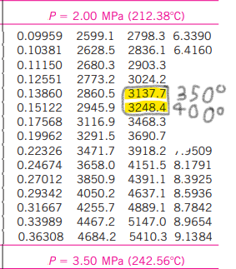
$$\left(3248.4-3137.7\right)*\frac{1}{5}+3137.7=h1=3159.84 kJ/kg$$
specific volume $v1=\left(0.15122-0.13860\right)*\frac{1}{5}+0.13860=0.141124$

H2 is steam, so we use same table: 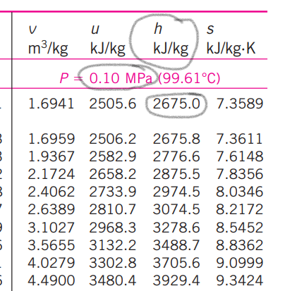
$$h2=2675 kJ/kg$$
- $A=\frac{\dot{m}*v}{V}=\frac{15*0.1411}{100}=0.02m^{2}$
- $0=\dot{Q}-7*{10}^{6}W+15 kg/s \left(\left(3159.84-2675\right) kJ/kg+\left(\frac{{100}^{2}-{50}^{2}}{2}\right)\frac{m^{2}}{s^{2}} +\left(9.81 *3\right)\frac{m^{2}}{s^{2}} \right)$ $\dot{Q}=7*{10}^{6}W-15\frac{kg}{s}\left(\left(484.84\right)\frac{kJ}{kg}+\left(3750\right)\frac{m^{2}}{s^{2}}*\frac{1}{1000} +\left(29.43\right)\frac{m^{2}}{s^{2}}*\frac{1}{1000} \right)$ $\dot{Q}=7*{10}^{6}W-15\frac{kg}{s}\left(488619.43\frac{J}{kg} \right)→-329291.45W=-329.3kW$

